You want to Link to Gradescope using a Gradescope Assignment using the ***Gradescope Assignment tool*** in Blackboard.

You could do this anywhere within a content area for students to click on to go directly to a Gradescope Assignment. But in this case it doesn’t even need to be visible to students, but accessible to you on an unused page in Bb.

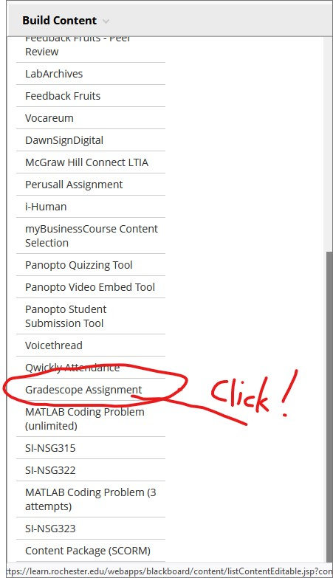The Gradescope Assignment link sets up the trust/2-way data permissions between the Bb Gradebook and the Gradescope Assignment:

1. If you're using Blackboard Original, go to your course homepage in Blackboard   
   > click **Course Materials** (left sidebar)   
   > click **Build Content**(header bar)   
   > select **Gradescope Assignment**.

This will launch Gradescope.

1. A screenshot of a computer

   Description automatically generatedWhen Gradescope launches, you will see a dialog box about assignment-linking. Decide whether you'd like to:   
   > Create a new Gradescope assignment

> Or link to an existing one (if you have any assignments already in this course).   
> Then, click the **Link Assignment** button.



1. A screenshot of a computer screen

   Description automatically generatedChoose the corresponding Assignment (the first assignment for your class), then don’t forget to save/update course button (scroll down) Look for that “Save” button in the lower right corner). This establishes the link between the Gradescope Assignment and the Blackboard gradebook.
   1. **When to link:**   
      If submissions will be **student-uploaded**, it's highly recommended that link your Gradescope assignment to Blackboard ***before*** releasing it to students so they can easily access the assignment via Blackboard.   
        
      If submissions will be **instructor-uploaded**, it's recommended that you ***wait*** to link the assignment until you're ready to publish grades.

Now go back to Blackboard once more,… and find the Gradescope Assignment Link you created.

Click your **Gradescope assignment link** in Blackboard to launch it. This last step should drop you into the assignment in Gradescope AND link your Blackboard course site to Gradescope.

If you're trying to release grades to the Blackboard Gradebook. In Gradescope Click **Review Grades** (left sidebar in Gradescope).



The Post Grades button should be in the footer of the Review Grades page now. Click on that submit the grades to the correct column in the Blackboard Gradebook.

If that didn't work, contact [help@gradescope.com](mailto:help@gradescope.com).

