Tips for a smoother AJE experience
November 29, 2022
- Budget dates, budget dates, budget dates!
- Determines which budget period transactions are associated with.
- Need to match original posting – for example if your AJE is transferring a $50 supply charge from OP234567 to GR567890 and that supply charge originally posted with a budget date of 8/31/2022, your AJE needs to have the same budget date.
- AJE’s for initial charges to GR’s vs. cost transfers (ex. service center activities, internal consulting work from a neighboring dept., etc.) the budget date is the date of service/date of delivery.

- The famous (or infamous) two questions required for all GR AJE’s:
1. Why was the cost originally recorded on the FAO/Grant from which it is now being transferred?
2. Why is this cost allowable and allocable to the proposed receiving FAO/Grant?

- Attachments –
- For cost transfers – attach a URF transaction report to evidence the original posting (also allows reviewers to verify budget dates) and answer the two questions (see “B” above). That’s it! There is no need to attach invoices, PO’s, emails, etc. for cost transfers. Less is more.
- For initial charges – attach an invoice/statement (on Dept./UR letterhead) clearly indicating the services performed/items supplied, the date of service, rate calculation if applicable (rate x hours, etc.), and the GR number to be charged. Make sure you are providing an active/current GR to service centers, UR Computer store, etc.
- AJE’s to change budget dates – attach a justification for the change in budget date. For example, if you paid an invoice in July for materials received and used in May and the SPI posted with a July budget date, process an AJE to change the budget date from July to May. Attach support for the change in budget date (supplier invoice, receipt, etc.).

- Journal lines – how many is too many? Ideally, AJE’s should be kept to 30 lines or less to enable timely review/approval each month. If you have an AJE with more than thirty lines, please break up into smaller AJE’s (150 lines total, do five AJE’s with 30 lines each) OR consider processing via an EIB (upload) – contact your divisional finance office for assistance.

- Has my AJE been approved yet? Review the process history:

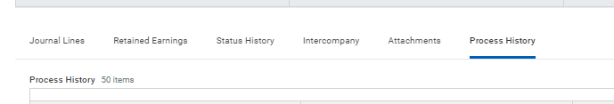

- Payroll reallocations via AJE – These should be avoided whenever possible since AJE’s bypass HRMS, the system of record for effort/payroll. Having said that, AJE’s are only permissible for movements of salary/benefits older than 18 months. For these AJE’s ORACS requires a fully executed 800 form, signed by the Dept. Chair and emailed to ORACS vs. attached in URF since PII is involved.

- 2 CFR 200 considerations – materials/services must be received and used prior to expiration of the award in order to be allowable/allocable on a GR. For example, if you ordered a piece of equipment in November and it doesn’t arrive until February, you cannot charge this to a project that ended January 31. It doesn’t matter that the item was ordered before the GR expired.

