UNIVERSITY OF ROCHESTER MEDICAL CENTER
OPERATING BUDGET PROCESS
PROVIDER MODEL
FISCAL YEAR 2020/2021
Provider Maintenance
- Accessing Provider Maintenance –click on the Axiom 2021 budget tab in the upper left hand corner and scroll down to Provider Maintenance Folder.
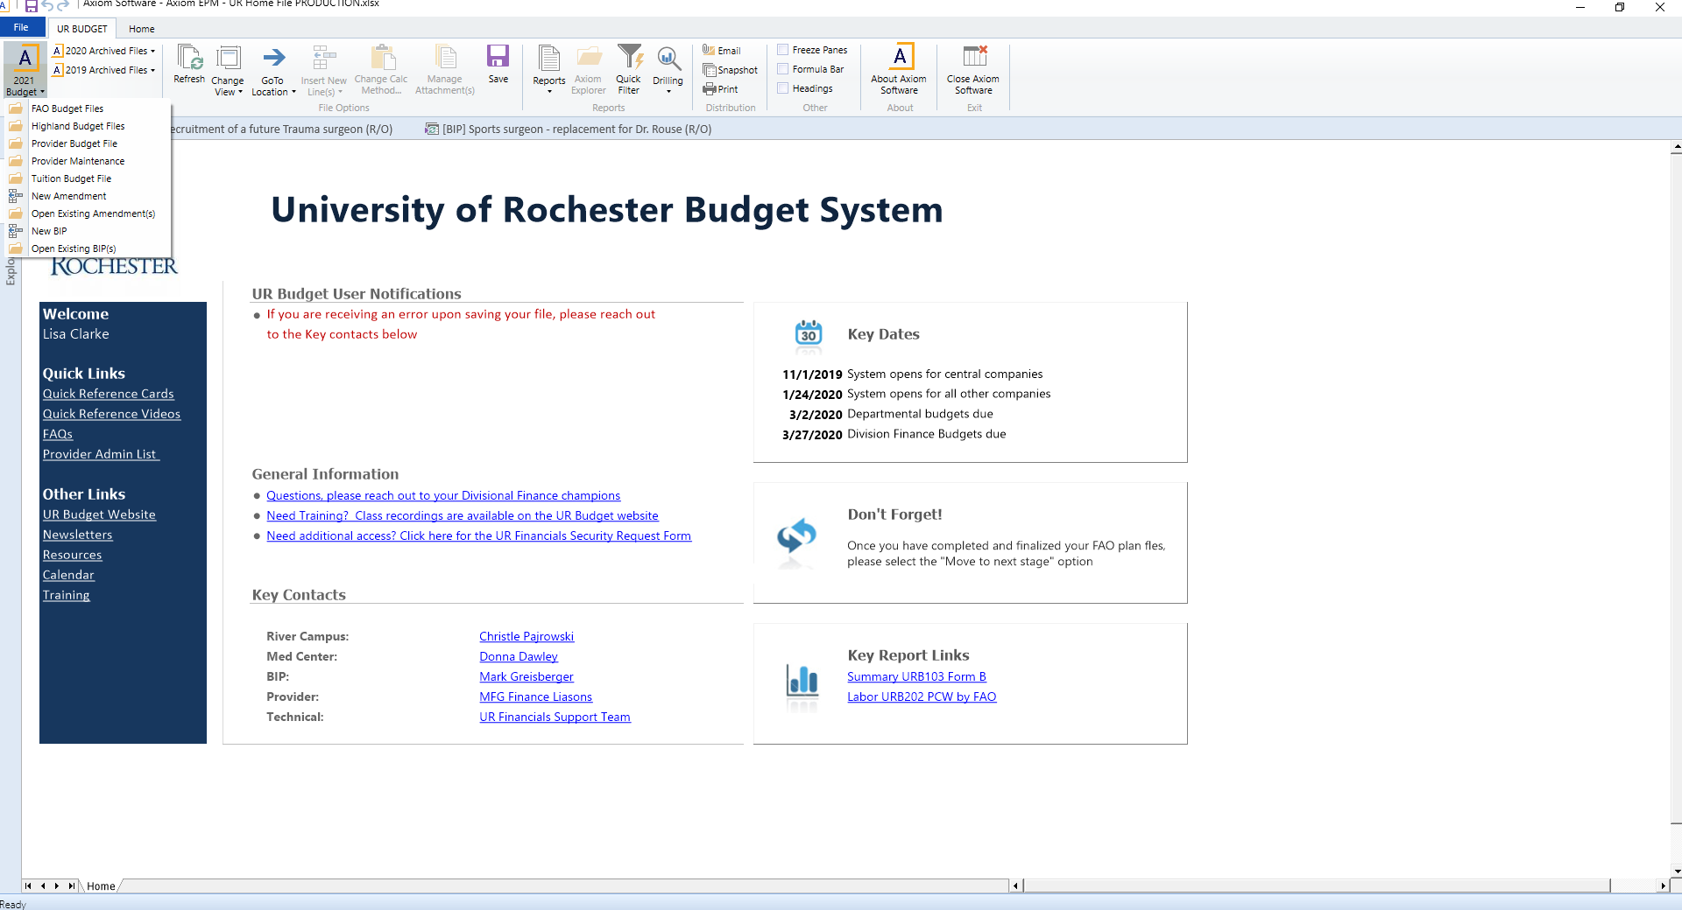
- Double click on Provider Maintenance and a menu for Cost Center Hierarchy will pop up.
- Choose a Cost Center Hierarchy (there may only be one to choose from).
- The first tab is New Providers. If there are any new providers since we last mapped to URID’s, please map them here. To map, click on yellow box, and choose Provider Name)
- The second tab is Current Providers. By utilizing the change view in the tool bar, select the Provider Group Assignments. Please review the Provider groups and change/add as appropriate for each provider.
- The second view is Benchmarks.
  - Please review and correct, if necessary, the MGMA Specialty designation for compensation and productivity. You can make changes by double clicking on the yellow box with three dots and choosing from the drop down menu.
  - Next, review and correct, if necessary, the Alternate Benchmark table for productivity and compensation for each non-APP providers. This should represent the benchmark table you use in your tool kit.
  - The last step is to assign, by using the drop down, the Alternate Specialty designation specific to your Alternate Benchmark Survey.
- The third tab is the Provider Tool Kit. This is currently in construction, but will be live shortly. Upon go live for this functionality, instructions will follow.

