INSTRUCTIONS FOR PROVIDER MAINTENANCE WITHIN AXIOM BUDGETING TOOL

- Accessing Provider Maintenance –click on the Axiom 2024 budget tab in the upper left-hand corner and scroll down to Provider Maintenance Folder.

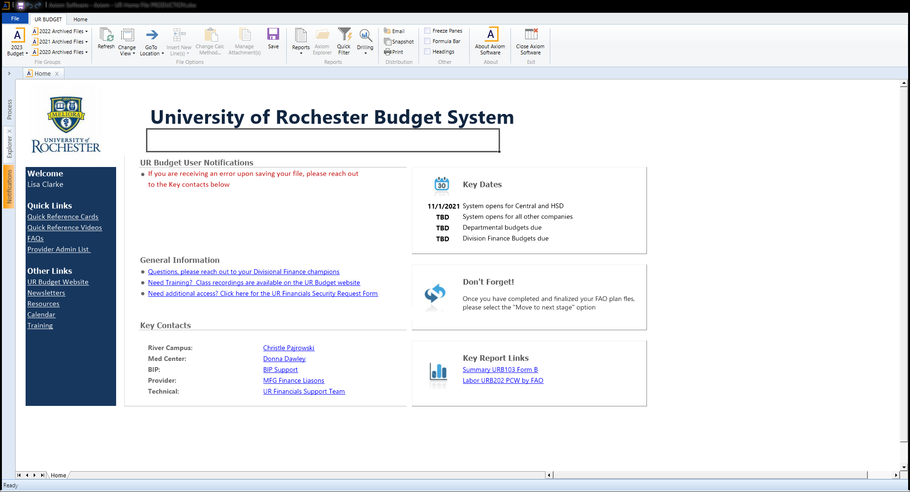

- Double click on Provider Maintenance and a menu for Cost Center Hierarchy will pop up.
- Choose a Cost Center Hierarchy (there may only be one to choose from).
- The first tab within your Maintenance Module is New Providers. If there are any new providers since the last time URID’s were mapped, they will be mapped within this tab.
  - When you open this window, depending upon if you added new providers, you will see a section for: Providers added through a BIP and Providers added through Provider Model (Replacement/Vacancies)
  - To map to a URID click on the orange cell with three dots. This will bring up a list of names. Type in the name you are looking for ( Last Name,First Name ). Do not hit enter, just wait, it does take a few seconds for the name to appear. If the name does not appear, it means that the individual has not been loaded into HRMS yet and a UR ID may not be assigned yet. You may have to check back in a month.
Note: sometimes there is a name listed (you knew the person coming when you did the budget), or it may just say replacement, or BIP XXX because at the time you may not have had an identified candidate.
- Once you have completed mapping the UR IDs, move to the next tab, called Current Providers.
  - You will see a section called Unmapped Providers and Mapped Providers. The system will automatically show a default provider group based on their HRMS assignment.
  - For unmapped providers, again use the orange cell, double click, and the list of Provider Models will appear. Even if the default is correct, you need to add the Provider Group here.
  - For mapped providers, you only need to complete this process if the mapping for current providers is incorrect. A lot of times APPS can move between provider models, so it may be necessary to make some changes for those occurrences.
  - The next step is to assign the segmentation. As a general rule, APPs should be mapped to Other. Research is typically someone on a research track, in a research department, low CFTE, etc. Clinical has a CFTE, involved in patient care, etc. You may have faculty that do not fall into Clinical or Research as the individual is all administrative, quality, etc. If you want to discuss these outliers feel free to reach out to Noah Chhibber at Noah_Chhibber@URMC.rochester.edu.
  - Once the above tasks are complete, click on the Change View button in the tool bar.
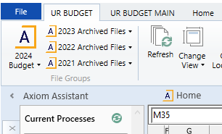

  - Pick the Benchmark assignment View
  - Review this tab – assign benchmark tables and specialties for both compensation and productivity if the cells are blank. This can be done by clicking on the yellow box. Also please review all existing assignments to ensure they are correct. NOTE: there is an option to pick AAMC PHD Research (this is primarily for PHD research faculty, but can also be used for PHD Clinical (such as PHD Psychologists). Don’t be afraid to mix benchmark tables in cases where the one you generally use does not include a specialty you need, but ensure that any benchmarks you choose do have data available this year as available specialties can differ year-to-year. This year will be the year we transition to the CMS 2021 RVU table. For productivity pick the benchmark that aligns with CMS 2021 – for example FPSC 2022, or MGMA-A. If you have any questions as to the appropriate productivity benchmark to choose contact Noah Chhibber. We will also be setting up workshops to aid in this transition.
- The next tab is for the toolkit. Similar to last year this will populate with the information you just completed. It will also pull in the budget data you enter in Axiom such as FTE components – CFTE, Admin FTE, etc., budgeted compensation and RVUs. YOU NEED TO CLICK ON REFRESH FOR THE FY24 BUDGET DATA TO POPULATE.

- The last tab is the Benchmarks. This shows the Tables currently loaded. As new tables are received they will be uploaded to Axiom.

If you need any help with the above process please reach out to your MFG Finance Liaison, Ray Bales or Noah Chhibber. If easier to work on this together via Zoom we can do this as well.

