Strong Memorial Hospital
FY25 Operating Budget Instructions

UR Budget Provider Model

Refer to Provider Model instructions on the UR Budget website for information on how to budget for providers (https://www.rochester.edu/adminfinance/urbudget/resources/budget-tools/ ). Please note that you must include work RVU’s regardless of company. If professional revenue has converted to SMH, wRVUs still need to be captured for compensation modeling and for revenue calculations. In addition, please pay special attention to defining administrative roles in ‘View 1 Effort Distribution’.

UR Budget Plan File (Labor)

- Faculty and APP: Make sure you agree with Faculty and APP positions and dollars being allocated to the FAO from Provider Model. If you do not agree, reach out to the Provider Group Administrator to review and discuss. The listing can be found on the tools section of the UR Budget website here: https://www.rochester.edu/adminfinance/urbudget/resources/budget-tools/. Changes can be made to Faculty and APP allocations until the system closes – make sure to check these allocations in the Labor Tab throughout the budget process. Any incremental positions should be budgeted in a BIP.

- Residents, Fellows, Postdocs, and Resident Non-MD: If an FAO has budget dollars in either SC58250 Resident and Fellows or SC57750 Fellow and Postdocs there will be an attachment uploaded to the FAO Plan File with instructions on how to budget. Complete the worksheet and input the salary and benefit budget into the Summary Tab as indicated. These positions are not budgeted on the Labor Tab.

- Staff: The Labor Tab will force all staff FTE to the CYB (authorized FTE). To change the CYB in UR Budget you will need to submit an FTE modification to SMH Finance.
  - For a jobcode with a CYB (authorized FTE) value but no employees populated, make sure that the job code adjustments work appropriately.
  - CYB (authorized FTE) values will continue to be updated throughout the budget process to reflect any approved modifications. You can add/remove positions to balance back to the CYB or let the UR Budget system auto-adjust to the updated CYB using the avg. rate in the jobcode.
  - Any vacant position added will default to the vacancy rate (110% of the hiring range minimum). Please manually update any salary as needed.
  - Do not process any CPM jobcode changes in the Labor Tab. These changes will be processed globally by Hospital Finance.

- Overtime, Shift Differential, On-Call, Holiday Premium, and Add’l Earnings: Generally, no budget should be added unless previously budgeted in the FAO. To change the budgeted amount for any of these categories a detailed worksheet must be attached outlining the changes and assumptions.
  - Ensure that the spreads are accurate.
  - BWH Holiday Premium (hours) are budgeted in the following months for FY25.
- Special Considerations:
  - If extra compensation is budgeted, the associated benefits need to be manually entered in the Staff Benefits (Lump Sum) SC46250 line on the Summary Tab. This amount will need to be added to any Resident benefit amounts which will be budgeted for in the same place.
  - Company level drivers will be used to update benefit rates and wage and salary. These drivers are currently pushing in placeholder amounts that may change during the budget process. The system will automatically update all FAO Plan File budgets if changes are made to these drivers.

- For additional information on the Labor Tab of the Plan File, please reference the QRC located in the training section of the UR Budget website: https://www.rochester.edu/adminfinance/urbudget/training/quick-reference-cards-qrcs/

UR Budget Plan File (Summary)
Please note: Summary Tab can also be found on the QRC page in the UR Budget website located here: https://www.rochester.edu/adminfinance/urbudget/training/quick-reference-cards-qrcs/

- Revenue:
  - Other Operating Revenue (Ledger 46000) should be budgeted in individual FAO files:
    - Update FY24 OOR Projection in the Summary Tab per current trends
    - Input FY25 budget and spread in the Summary Tab
      - Attach support for the FY25 OOR calculations to the FAO file.
      - FY25 budget should only reflect changes to the core budget, any incremental OOR should be input through a BIP.
  - Professional Billed revenue will feed into the Summary Tab from the Provider Model, including both the FY24 Projection and the FY25 Budget.
  - Hospital Billed Outpatient Charges – The FY24 Projection is calculated on a straight-line basis. If you have a program change that began in FY24 that should be annualized, please modify the charge projection and any related expenses. This projection will carry forward into the FY25 Core Budget. Charges for FY25 can be modified as well to incorporate the annualization of these program changes. An estimated contractual allowance is calculated in the Axiom Dashboard report so if you run this report, you will see the estimated contractual, which combined with the charges, is a proxy for Hospital Billed Outpatient technical revenue. Please note that these are only estimates for Budget Meeting purposes only. Your final FY25 Charge Budget will be calculated by the revenue team at the end of the budget process (similar to prior years).
  - If Hospital Billed Inpatient Charges are within your FAO, please do not modify the FY24 Projection or the FY25 Budget. These charges will be addressed through your Inpatient Case Projections.

- Salary:
  - Review and update FY24 Projection by Spend Category if needed.
  - Most salary budgets will populate the Summary Tab from the inputs in the Labor Tab. The exception to this is any salary line that uses the ‘base + changes’ method (extra compensation, resident, undergraduate students, etc.). These should be budgeted for in the Summary Tab as appropriate. (See Labor above #2 on specific instructions for Residents, Fellows, Postdocs, and Resident Non-MD)

- Non-Salary:
  - Review all non-salary budget items in the FAO at the spend category level.
  - Review and update the FY24 Projections based on historical and current spending patterns. Working with your SMH Finance representative, please compare to the FY25 budget and make appropriate modifications as necessary.
    - Any FY24 year budget modification or BIP will have additional budget dollars added to the FY25 preliminary budget to annualize partial year amounts.
      - For example - if a FY24 budget modification added $80,000 in medical supplies for Nov-June, an annualization amount of $40,000 will be added to the FY25 preliminary medical supplies budget. This makes it so the whole year expense of $120,000 is included in the FY25 budget submission, for your convenience, without any additional manager input modifications.
    - Any increase in budget dollars needs to have proper documentation as to the need and total dollar amount. Please attach a detailed analysis along with any supporting documentation and indicate the change in the comment section.
  - If you cannot find the correct subtotal group to add a spend category to your plan file, refer to the ‘Sub-Total to Ledger Account to FAC Map’ document on the UR Budget website here: https://www.rochester.edu/adminfinance/urbudget/resources/budget-tools/
- Update any spreads that do not follow the default spread methodology.

- Special Considerations:
  - URMFG Company and CBO assessment budgets will automatically calculate from the professional billed revenue coming into the plan file. You do not need to adjust.
  - Please ensure your ‘FY24 Final Proj’ is accurate and update in Axiom when necessary. Please note: ‘FY24 Final Proj’ will automatically feed into the Departmental Dashboard to be reviewed at your Budget Hearing.
  - QA budgets should be budgeted as a normal FAO while staying within the authorized budget amount.
  - Comments should be included with any changes made.
  - Update external rent based on agreements/contracts in place.
  - No spend categories should include inflation. Various inflation adjustments will be addressed on a company level.
Reporting
- Run the following reports (some specific to SMH) to review your hospital budget.
  - URB204 SMH Salary Summary
    - Use this report to evaluate hospital FTEs – the ‘Jobcode Adjustment’ view will show you total FTEs included in the plan file AND offsetting jobcode adjustments that push the jobcode back to authorized FTEs. Other PCW/FTE views and reports may not include jobcode adjustments and cannot be used to evaluate total FTEs included in your SMH budget.
  - URB103 Form B
  - URB203 Salary and Benefit Summary
  - URB105 Modification Summary
  - MFG Dashboard (can run by SMH only)
    - Run this report after all adjustments and modifications have been made to the FY24 Projection and the FY25 Budget, to ensure your requested budget looks reasonable. Please note an automatic calculation of contractual allowances on hospital billed charges is included in this report. The purpose of this is to show all revenue sources at net estimated amounts to be collected for review at the Budget Meeting.

Business Improvement Plan Information

- A Business Improvement Plan will be required for all new programs and expansion of existing programs that include incremental expenses and corresponding revenues or fund transfers from other UR Medicine entities. Example scenarios that require a BIP:
  - Adding new Faculty or APPs to capitalize on patient demand.
  - Adding APPs to new meet demand or optimize provider efficiency.
  - Expanding clinic hours to meet patient needs while requesting incremental staffing.
  - Opening a new location either locally or regionally
  - Hospital-Based Conversions – outlining incremental revenue enhancements or expense reductions.
  - Acquisitions
  - New equipment that will support new clinical volumes.
  - Replacing faculty not currently in budget.
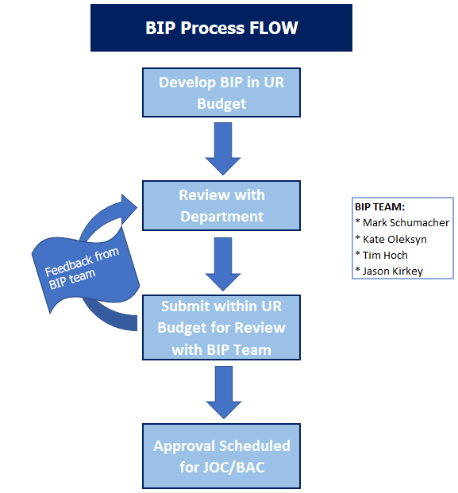
- A Business Improvement Plan is not required when requesting incremental resources to right-size the core budget. These requests will still require justification to be built into the core budget including productivity measures to ensure efficient use of resources (example ‘b.’ below). Additionally, replacement faculty will not require a BIP. Rare exceptions may exist if the replacement is in a highly specialized area or if the department anticipates multiple replacements for a single departure. Divisional Finance will provide guidance on exceptions. Example scenarios that do not require a BIP:
  - Replacement of a Faculty with no significant change anticipated.
  - Increased support staff to meet existing physician volumes (ex. OAS, nurses, techs, etc.) – Productivity Measures needed
  - Replacing staff vacancies
  - Inflationary or trend increases in the existing budget.
FY 2025 SMH Finance Representatives

Your SMH Finance Representative will not only be your financial partner throughout the FY 2025 budget cycle but will be an added resource as you look to implement your FY 2025 budget plans.
