Live Captioning in Zoom

In your Zoom meeting, click on “Closed Caption” at the bottom of your screen.
Click “Copy the API Code.”

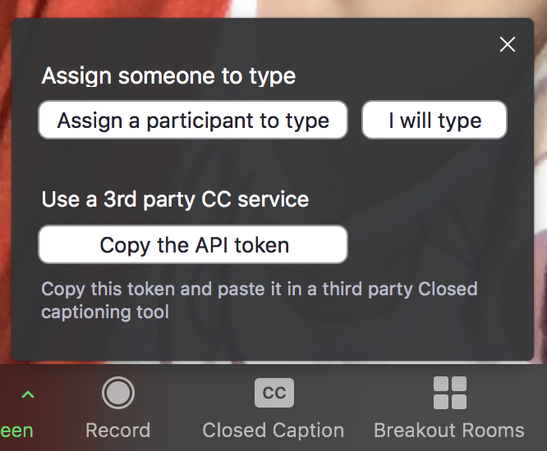

In your internet browser, visit https://webcaptioner.com/captioner/

At the bottom, click “Start Captioning” and then click the three little dots icon next to it, followed by “Settings.”

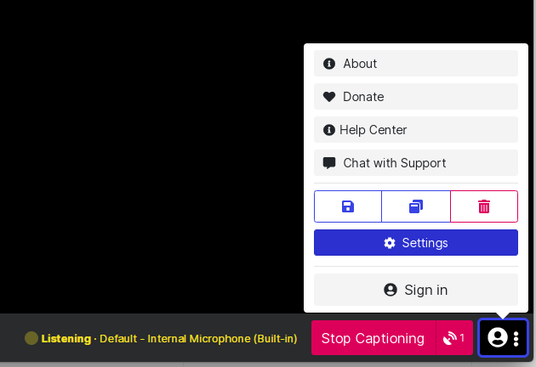

In the yellow menu on the left, select “Channels.”
If you are doing this for the first time, you’ll need to select Zoom from the options shown. If you are returning, Zoom will be listed as a Channel and you’ll need to click “Configured” next to it.

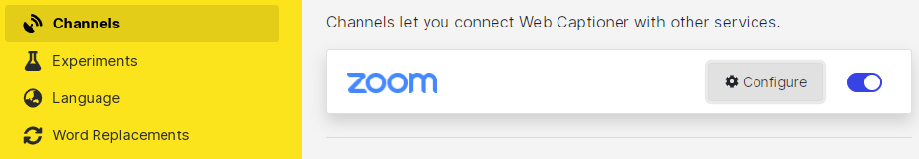

Paste the API code from Zoom into the necessary box.

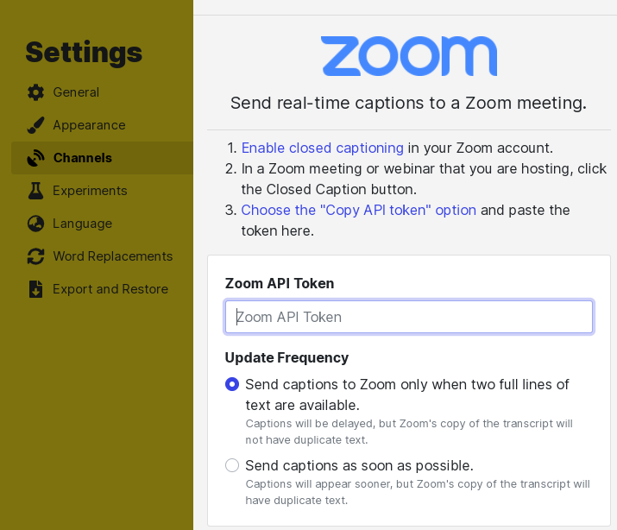

Auto-captions should now appear on your Zoom meeting!

