Zoom Live Captioning

Zoom has an auto-transcription/captioning feature built in using artificial intelligence.

Important points:
- Auto-transcription has to be enabled by the host of the meeting
- Meeting participants have the ability to show or hide captions/subtitles on their individual screens
- Automatic captions may not be accurate enough to provide access for all individuals with disabilities. Real time captioning, using a professional hired captionist, should generally be arranged for any meetings when captioning is required for disability access. Please consult with attendees and/or Disability Resources if you have any questions about the appropriate kind of captioning for your event.
- Auto-transcription should be turned off for meetings in which there is a human captionist assigned

To turn on auto-transcription as the meeting host:
- Start a new meeting
- Click the “Live Transcript” button at the bottom of the Zoom window
- Select “Enable Auto-Transcription”
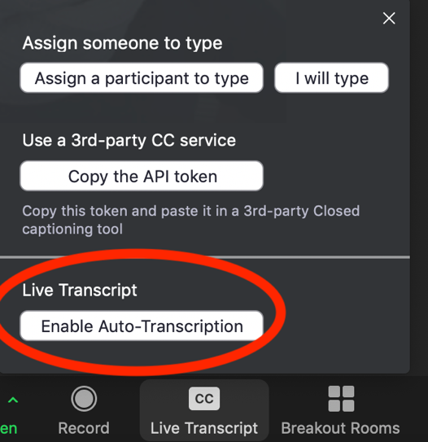

To view captions as a meeting attendee:
- Click the “Live Transcript” button at the bottom of the Zoom window
- Select “Show Subtitle” for captions to appear on screen
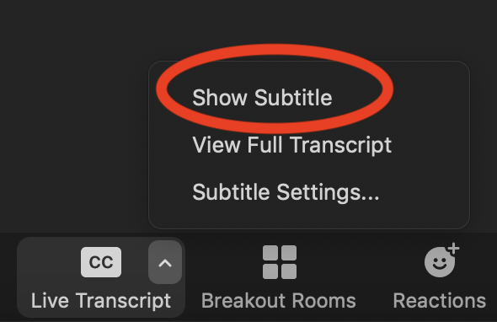

To save a transcript of the meeting
- Click the “Live Transcript” button at the bottom of the Zoom window
- Select “View Full Transcript.” A panel will appear on the right side of the Zoom window with full meeting transcript.
- At the end of the meeting, click on “Save Transcript” at the bottom of that panel
- The transcript will be saved as a .txt file in the Zoom meeting folder on your computer

Captioning Recorded Zoom Sessions
Auto-transcription/captioning is not retained on the mp4 files of recorded Zoom sessions.

To add auto-generated captions to your Zoom recordings (please note that these captions can and should be edited for accuracy):
- Use Panopto/Blackboard to add automatic captions
- Use YouTube to add automatic captions

OR

Use fee-based services to add accurate captions to your video. Suggested vendors:
- Rev
- 3PlayMedia
- Caption Sync

